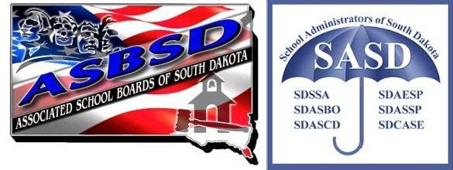
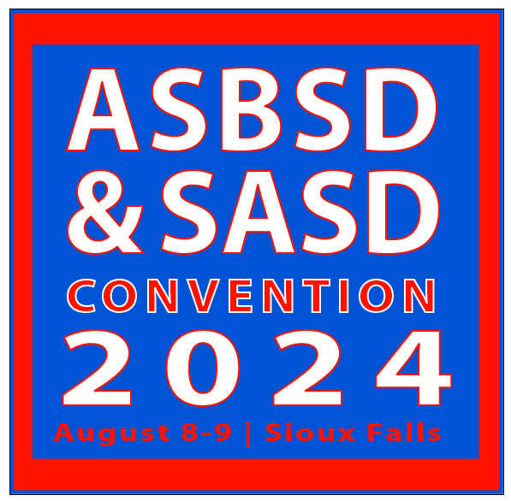

EXHIBITOR INFORMATION

This collection of resources provides all the information you need to become part of the state’s largest education conference developed specifically for school leaders.

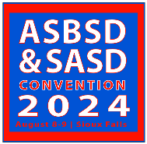

FREQUENTLY ASKED QUESTIONS

FAQ: WHO COMES TO CONVENTION?
The ASBSD and SASD Convention is South Dakota’s most comprehensive and well-attended professional development conference for school district leaders. We attract more than 500 school board members, superintendents, business officials, principals and other school administrators. Our conference attendees recommend your products and services, build budgets and approve district spending. In short, our convention attracts the full spectrum of school district decision-makers.

FAQ: ARE WE ALLOWED TO MAKE A BREAKOUT PRESENTATION TO YOUR MEMBERSHIP?
If you believe you have a topic that is of interest to our members, you can submit a presentation proposal to Tyler Pickner at tpickner@asbsd.org. No vendor will be considered for a presentation without first purchasing a booth in the exhibit hall, and other
considerations also apply. If you’d like to guarantee an opportunity to present to our members, your organization can sponsor a featured breakout session. For more information, see the Sponsorship Opportunities page.

FAQ: WHAT DO CONFERENCE GOERS LOOK FOR?
When asked the main reasons they visit exhibits, conference-goers list “learning about new products and services” as their first priority, with “learning about the latest issues” coming next.

FAQ: I NEED AN INTERNET CONNECTION, WHAT DO I DO?
A wireless network connection will be available for all conference goers and for exhibitors.

FAQ: I NEED ELECTRICAL OUTLETS OR OTHER ACCOMMODATIONS, WHAT DO I DO?
If you need electrical outlets or any other special accommodations, you must coordinate those add-on services with the Sioux Falls Convention Center. Contact Tyler Pickner for more details.

FAQ: WHAT TIMES ARE SET ASIDE FOR VIEWING EXHIBITS?
We’ll start early on Thursday morning by registering members and serving breakfast in the exhibit hall from 7:30 – 9:00 a.m. After our noon Awards Banquet, we’ll give our members another hour to walk through exhibits. The set-aside time is in addition to the traffic you will experience during Convention programming.

FAQ: WHAT CAN WE DO TO STAND OUT?
Consider reserving more than one booth. The more space you have, the more you stand out.

FAQ: CAN I BRING FREEBIES?
Absolutely! What’s an exhibit hall without freebies? However, the Convention Center does regulate the size and amount of food and beverage exhibitors can give away. Food and beverage samples must not be greater than 3 oz. and must be manufactured, processed or distributed by the exhibiting firm and must be related to participation in the event. For more information on food samples, contact Tyler Pickner.

FAQ: WILL THERE BE A DOOR PRIZE DRAWING?
Exhibitors can offer door prizes, conduct prize drawings from the booths and arrange prize delivery or pick-up.

EXHIBITOR CONTRACT
Booth placement will be determined on a first-come-first-served basis. Please pay special attention to the deadlines on the accompanying materials. Please type or write legibly. Fill out information in black ink.
EXHIBITOR INFORMATION
Organization: Address: City/State/Zip: Representative(s) that will attend: Phone: _ Fax: Email:
Product/Service: The Product/Service information will be posted on the ASBSD website

EXHIBITING AT CONVENTION
Here’s what you need to know about exhibiting at the 2024 ASBSD and SASD Convention:
- Set-up will begin at 1:00 p.m., Wednesday, August 7, 2024
- On Thursday, August 8, the exhibit hall will be open from 7:30 a.m. to 4:00 p.m.
- Cost of exhibit space rental is $525.00. Non profit rate is $125.00. We do not accept credit cards.
- This application form, along with payment, must be sent to ASBSD by July 12, 2024.
- The rental fee includes a 10’ x 10’ booth space, backdrop, a table, two chairs and a listing in the official convention program.
- If you need electrical outlets or any other special accommodations, you must coordinate those add-on services with the Sioux Falls Convention Center. ASBSD can assist you by providing ordering forms and additional information.
AGREEMENT
The Undersigned hereby authorizes ASBSD and SASD to reserve exhibit space at the Sioux Falls Convention Center, Sioux Falls, SD, for use by the above organization during the 2024 ASBSD and SASD Convention. The undersigned hereby acknowledges receipt of and agrees to abide by the Exhibit Rules and Regulations, and to all conditions under which exhibit space at the Sioux Falls Convention Center.
Authorized Signature: Print Name:

RETURN ADDRESS INFORMATION
Please return this form, along with the $525 rental fee, by July 12, 2024 to: ASBSD and SASD Convention
PO Box 1059
Pierre, SD 57501
605.773.8382 (phone)::605.773.2501 (fax)

FOR ASBSD USE ONLY
Confirmation Faxed: Booth Assigned:

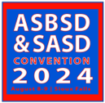

EXHIBIT HALL RULES AND REGULATIONS
EXHIBITOR SHALL BE BOUND BY THE RULES AND REGULATIONS set forth herein and by such amendments or additional rules and regulations which may be established by the exhibit manager and any duly authorized representative, agent or employee of the sponsoring organizations.

EXHIBITORS ARE FURTHER BOUND BY all Sioux Falls Convention Center policies and regulations.

EXHIBITORS ACKNOWLDEGE that it is the sole responsibility of the exhibitor to conform to all Sioux Falls Convention Center policies and regulations.

EXHIBITORS ACKNOWLEDGE that Sioux Falls Convention Center policies and regulations are available for review and inspection, and that copies of convention center policies may be obtained by contacting ASBSD.

STANDARD BOOTH EQUIPMENT consists of upright posts, drapes, a table and two chairs. Each booth is 10’ x 10’. Exhibitors having their own custom built displays cannot exceed those of the standard booths. Standard booth background drapes may not be removed. Any non-standard equipment, including but not limited to audio visual equipment or electrical needs, must be arranged with the Sioux Falls Convention Center using the forms provided by the exhibit manager.

INSTALLATION OF EXHIBITS will begin on Wednesday, August 7, 2024, from 1:00 p.m. to 8:00 p.m. Per Sioux Falls Convention Center practice, exhibitors should use the exhibit hall loading doors (located on the North end of the Convention Center) to move exhibits into the exhibit hall. The hours for display are Thursday, August 8, from 7:30 a.m. to 4:00 p.m.

REMOVAL OF EXHIBITS shall begin at 4:00 p.m. on Thursday, August 8, and must be completed the same day. Take-down may be earlier if traffic flow has diminished and approved by exhibit manager.

SPECIAL EQUIPMENT AND LIGHTING for displays is the responsibility of the exhibitor. Lighting in the exhibit area is ample for all ordinary purposes.

DECORATIONS MUST BE 100% FIRE-RESISTANT and no LP or flammable liquids may be used in the exhibit.

SUBLETTING OR DIVIDING exhibit space is not allowed except by permission of the exhibit manager. Distribution of material and display must be limited to the booth rented.

MARRING, TACKING OR DEFACING the wall is not permissible. HOSPITALITY will not be observed in conflict with the general convention schedule. EXITS MUST be kept clear at all times.
THE CONVENTION SPONSORS RESERVE THE RIGHT to restrict exhibits which may become objectionable. This includes persons, things, conduct, printed matter or anything not in keeping with the educational character of the exhibits.

BOOTH RENTAL FEE WILL NOT BE REFUNDED if the space assignment is canceled after July 12, 2024.

SPONSORSHIP OPPORTUNITIES
When your organization sponsors an event at the ASBSD and SASD Convention, we want you to stand out! That’s why we only offer a few high-exposure sponsorship opportunities each year. All sponsorships valued at $2,500 or more include a FREE exhibit hall booth and FREE half-page ad in the official convention program – a combined $700 value! Every sponsor will also be listed in the official Convention program.

OPENING KEYNOTE SPEAKER – $5,000
Each year, ASBSD and SASD line up top-level education speakers for general sessions. Sponsoring a convention keynote speaker gives your organization top-billing in the program, and we’ll use your organization’s name when we reference our keynote speaker – both in the convention program and in media releases.

CLOSING KEYNOTE SPEAKER – $5,000
Each year, ASBSD and SASD line up top-level education speakers for general sessions. Sponsoring a convention keynote speaker gives your organization top-billing in the program, and we’ll use your organization’s name when we reference our keynote speaker – both in the convention program and in media releases.
ASBSD AND SASD AWARDS BANQUET – Reserved
Take advantage of this opportunity and benefit from the highest exposure of any event we hold at Convention – nearly everyone joins ASBSD and SASD Thursday afternoon to recognize outstanding achievements in public education. We’ll announce the sponsorship at the event and in the conference program, and will prominently display your organization’s logo.
OPENING DAY EVENING RECEPTION – Reserved
The opening day evening reception is a sponsored activity, meaning the reception will be named after the sponsoring organization. The reception is held Thursday evening – after the first full day of convention. Event sponsors can stand at the door, greeting conference-goers as they walk in.

EVENING RECEPTION REFRESHMENTS – $3,000
As the reception refreshments sponsor, you will help our members unwind during our opening day reception. After the first full day, our members will be able to relax with a selection of beer, wine and assorted non-alcoholic beverages – and they’ll have you to thank!
OPENING DAY BREAKFAST – $6,000 OR 2 Sponsors at $3,000
On the first day of Convention, we register conference-goers and provide breakfast in the exhibit hall – and your organization can have the exclusive opportunity to welcome them to convention. The opening day breakfast sponsor will get time to address conference-goers as they begin their day.
CLOSING DAY BREAKFAST – $6,000 OR 2 Sponsors at $3,000
The Friday morning breakfast is your last chance to make an impression on our members. The sit-down style breakfast allows you to station branded materials throughout the room or on table-tops.
OPENING DAY REFRESHMENTS – $6,000 OR 2 Sponsors at $3,000
Your sponsorship provides refreshment tables throughout the convention center during the convention’s first full day. A selection of bottled water, coffee and pop will allow conference-goers to grab a quick beverage throughout the day. We’ll work with you to put up appropriate branded signage that will remain present and visible as long as refreshments are provided.

CLOSING DAY REFRESHMENT – $2,000
Your sponsorship provides refreshment tables throughout the convention center during the convention’s final half-day. A selection of bottled water, coffee and pop will be provided to our members courtesy of your organization. If you’d like, we’ll arrange for signage to be placed on all refreshment stations.

BREAKOUT SESSION – $525
Want to deliver your message during a Convention breakout session? Sponsor a breakout session and you’ll receive a spot in the programming line-up and 50 minutes to talk with our members. Booth rental is required. Limited spaces are available.

SPONSORSHIP CONTRACT
Sponsorships will be granted on a first-come-first-served basis. Please pay special attention to the deadlines on the accompanying materials. Refer to the “Sponsorship Opportunities” sheet for a complete listing of opportunities. Please type or write legibly. Fill out information in black ink.
SPONSOR INFORMATION
Organization: Address: City/State/Zip: Representative(s) that will attend: Phone: Fax:
Email:
Product/Service: Sponsorship requested:

SPONSORSHIPS VALUED AT MORE THAN $2,500 INCLUDE:
- A complimentary booth space in the exhibit hall (a $525 value), along with a listing in the conference exhibitors portion of the program.
- A complimentary half-page advertisement in the convention program (a $175 value; see attached “Program Advertising” sheet for ad specifications).
- Coordination with the Sioux Falls Convention center to place corporate signage.
- Public recognition at one or more of the general sessions.
AGREEMENT
The Undersigned hereby authorizes ASBSD and SASD to reserve sponsorship rights for the event specified in this contract at the ASBSD and SASD Convention at the Sioux Falls Convention Center, Sioux Falls, SD, for the above organization. The undersigned hereby acknowledges the conditions of this contract.
Authorized Signature: Print Name:

RETURN ADDRESS INFORMATION
Please return this form, along with payment, no later than July 12, 2024 to:
ASBSD and SASD Convention PO Box 1059
Pierre, SD 57501
605.773.8382 (phone)::605.773.2501 (fax)

CONVENTION PROGRAM ADVERTISING
Advertising space in the official ASBSD and SASD Convention Program is reserved on a first-come-first-served basis. Please pay special attention to the deadlines on the accompanying materials. Please type or write legibly. Fill out information in black ink.
ADVERTISING INFORMATION
Organization: _ Contact Name and Email:_ Address: City/State/Zip: Advertisement Size Advertisement Cost

RATE AND SIZE INFORMATION
To ensure a clean and professional appearance for the official ASBSD and SASD Convention program, all advertising must conform to the following ad specifications. ALL ADS ARE COLOR.
PREMIUM PLACEMENT: Reserve your space on the inside front cover, inside back cover or back cover. Dimensions are 8.5” wide by 11” high. Premium placement ads are full color ads. Price: $425.
FULL PAGE: Dimensions are 8.5” wide by 11” high. Price: $325

HALF PAGE: Dimensions are either 7.5” wide by 5” high (horizontal half-page) OR 3.75” wide by 10” high (vertical half-page). Price: $175

TRANSFER
Ads can be sent, via e-mail, tpickner@asbsd.org. PDF or JPEG Format. If necessary, ads will be given a border.

RETURN ADDRESS INFORMATION
Please return this form, along with payment, no later than July 12, 2024 to: ASBSD and SASD Convention
PO Box 1059
Pierre SD 57501
605.773.8382 (phone)::605.773.2501 (fax)

